MidTerm Exam Review W/S B Name

**1**. What does the 7 in each number mean? What does the 3 in each number mean?

1. 7030 b) 30 720

**2.** Estimate the following:

a) 100 x 42 b) 2540 ÷ 11 c) 30 030 ÷ 9

**3.** Circle the greater number.

a) 4503 or 4305 b) 16 248 or 8416 c) 20 003 or 23 000

**4.** Tell what operation or combination of them (add, subtract, multiply or divide) you would do to solve the problem. Write the numbers and the operation signs you would perform. You do not need to solve them!

Hockey game: 342 spectators Soccer match: 174 spectators

1. How many more people were at the hockey game than at the soccer game?
2. How many more than 400 people are there at both events?
3. There are twice as many people at a speed skating event as at the soccer game. How many people are at speed skating?
4. 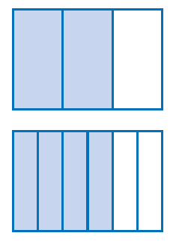Half of the people at the hockey game purchased 50-50 tickets for $2.50. How much money was collected?

**5.** What fraction does each diagram represent? Which one is larger?

**6.** Circle all the fractions below that are between 0 and $\frac{1}{2}$.

What operation did you need to do, in order to solve the problem?

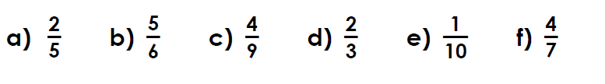

**7. $\frac{5}{12}+ \frac{10}{12}$** **8**. $\frac{3}{4}+ \frac{2}{5}$

**9. $\frac{3}{4}$** - $\frac{5}{8}$**10. $\frac{7}{12}$** x $\frac{2}{7}$

**11.** 2 x 6 **12.**  ÷

13. Owen can purchase a Mars Bar at the corner store for $1.20. The owner says today they are having a special where he can buy them for $\frac{1}{8}$ less than the normal price. **How much will he pay for his Mars Bar today?** Show your work.

**14.** The 25 students in a certain Secondary 1 class sold chocolate bars to raise money to finance their school activities for the year. Through this sale, they raised $8, 250. They kept  of this amount to pay for the first activity, a trip to Quebec City. **How much did it cost each student to go on the trip to Quebec City?**

**15.** Write a number to match the description as a decimal and then as a percent:

a 2 in the tenths place b) a 9 in the hundredths place

**16.** Put the numbers in order from least to greatest:

1. 1 , 0.01 , 0.1 , 10 , 100 ………………… b) 0.49, 0.7, 0.36, 0.2, 0.11……………………….....

**17.** Complete the following table. Fractions must be in lowest terms.

|  |  |  |
| --- | --- | --- |
| **FRACTION**  [lowest terms] | **DECIMAL**  [2 decimal places] | **PERCENT**  [No decimals] |
| $$\frac{3}{16}$$ |  |  |
|  | 0.024 |  |
|  |  | 56% |

**18.** Solve. Round to 2 decimal places.

|  |  |  |  |
| --- | --- | --- | --- |
| 0.56 x 4 | 98.43 ÷ 3.45 | 856.34 x 3.1 | 78.486 ÷ 12.48 |

**19.** Solve. Show your work. Show the process you used to solve.

|  |  |
| --- | --- |
| 89% of 30 | $\frac{3}{4}$ of 80 |
| $\frac{2}{5}$ of 24 | 0.99 of 13,345 |

**20. a)** (-34) + (+67)  **b**) (-1)+(-2)+(-3)+(-4)

**21. a)** 17 x (-3) **b)** (-5) x (-3) x (-2)

**22**. a) (8–7) x (6÷3)²  **b)** 4 ÷[5 + 9 x 1–(3+10)]

**23**. The Sens Store is offering clients a ‘SENSational’ sale in the month of February.

**Calculate the total bill [including the Ontario HST 13%] if a customer were to purchase the following items:**

|  |  |  |  |  |  |  |
| --- | --- | --- | --- | --- | --- | --- |
| Item | # | Price | Discount | Equation to Solve | Calculate $ discount | Sale Price |
| Sens hats | 2 | $24.00 | 20% |  |  |  |
| Sens Under Armour Golf Shirts | 1 | $55.00 | 15% |  |  |  |
| Sens Accessories (mugs, key chains, flags, | 2 | $7.00 | 40% |  |  |  |
| personalized Sens RBK jerseys | 4 | $260.00 | $$\frac{120}{200}$$ |  |  |  |
| Scratch Card: Show at register for further savings on total purchase | | Total  Purchase | 25% |  |  |  |
| Operation used to determine subtotal: ………………. **Subtotal** | | | | | |  |
| **Show calculations for determining tax on subtotal:**  13% = As a fraction:…………………. + Ontario HST 13%  13% = As a decimal: ………………..  Calculations: | | | | | |  |
| **Total** | | | | | |  |

**24.**

$\left[\frac{3}{16} ÷ \frac{1}{4}\right]+ \left[\frac{2}{3}- \frac{1}{8}\right]$