MidTerm Exam Review WS A Name

1. Are the two 9s in the number 9090 worth the same value? Explain.

2. Find two descriptions that match each number in the table below. Write the two letters for the matching descriptions underneath the number.
3300 30 330 33 030
A – Thirty thousand three hundred thirty | D – 3 ten thousands + 3 hundred + 3 tens
B – Three thousand three hundred | E – Thirty three thousand thirty
C – 3 ten thousands + 3 thousands + 3 tens | F - 3 thousands and 3 hundreds

3. Identify the fractions represented by the shaded part. Circle the LARGER fraction for each.
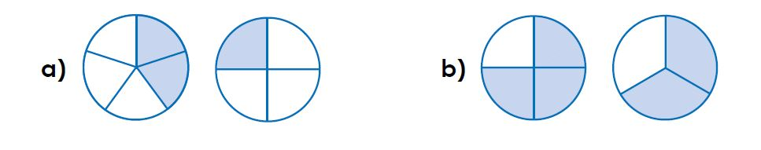

4. $\frac{30}{40}+ \frac{1}{2}= ____$

6. $\frac{7}{8}$ - $\frac{1}{12}$ =
5. $\frac{7}{8}÷\frac{3}{4}$ =

7. 2 x $\frac{1}{3}$ =

8. A recipe requires $\frac{1}{4}$ teaspoon cayenne pepper, $\frac{1}{3}$ teaspoon black pepper, and $\frac{1}{8}$ teaspoon red pepper. How much pepper does the recipe need?

9. Write in the words that best match the decimal

- 0.5 ¼ of something
- 0.25 almost a whole
- 0.32 about 1/3 of something
- 0.98 ½ of something

10. To make 5 litres of a fruit cocktail, Tamara mixed the following ingredients:
Orange Juice | Pineapple Juice | Grapefruit Juice | Lemon Juice
$1\frac{3}{4}$ litre | $1\frac{1}{3}$ litre | $\frac{5}{6}$ litre | ? litre
a) Convert to Improper. Show your work.
b) Convert to common denominator. Show your work.
c) Add all the fractions together
d) Subtract total from whole:

Solve: How many litres of lemon juice will she have to add to the mixture?

11. The full grid represents one whole.
Write the fraction, decimal and the percent for how much is shaded for each.

12. Fill in the table
Fraction | decimal | Percent
$$\frac{14}{60}$$
 | 1.35
 |  | 475%
$$\frac{5}{6}$$

13.
45 % of 148 = | 0.30 off $350 =
2% of $12,000 = | 50% of 200 =

14. The price of a new Tesla is $44,500. To purchase this car a down payment of $8,750 is required. What percent is the down payment of the regular price? Show your work.

15. Ms. Jackson is planning a school hiking trip to the Adirondacks. She needs to pay a 15% deposit from the total cost by a certain date. In order to do that, she needs to present that information to her Principal and the School Council for approval.
We have the following information:

- There are 987 students in the whole school.
- $\frac{5}{9}$ of the students are boys
- 450% of the girls are going on the field trip
- $\frac{1}{3}$ of the boys are going on the field trip

- The price per student is $126, including tax.

What is the total deposit that Ms. Jackson must present to the Principal and School Council?

16. Would each of the following result in a negative and/or positive value?

- A temperature drop of 10 degrees …
- Deep sea diving ………
- Earning $1200 …………………………...
- $40 in debt …………………………………

17. a) (-13) + (+5) b). 98 – (-34) – (-87)

18. Metal mercury at room temperature is a liquid. Its melting point is -39°C. The freezing point of alcohol is -114°C. How much colder is freezing point of alcohol than the melting point of mercury?

19. a) 8 x 1⁵ – 12 + 7 x 2 b) 9 ÷ 3 + 17 x 2

20. Erik and his uncle won $3000 at the Sens game last week in the 50/50 contest. They are going to give half of it to charity, $200 to Erik’s grandma, and they will split the rest between the two of them.

a) Write this situation as one single expression, showing all necessary operations
b) Solve

21.a) $\frac{3}{5}$ $÷$ $\frac{1}{4}$ x $\frac{2}{3}$ b) $\left[2\frac{1}{3}- 3\frac{1}{2}\right] X \left[5\frac{1}{2}- 3\frac{3}{4}\right]$

c) 7⁰ – [(-6)² ÷ (4.7 + 7.3)]

